**CSC 111 1.0 COMPUER PROGRAMMING - LABORATARY**

**FLIGHT RESERVATION SYSTEM**

***TRIPLE CODE***

***Date of Submission :- 2017.01.05***

**B.W.G.A.SANDARUWAN**

15ASP296

AS2015540

**W.M.C.T.WIJESINGHE**

15ASP372

AS2015604

**W.P.M.JAYASIRI**

15ASP153

AS2015421

**CONTENT**

* Introduction
* User Manual
* Input and Output
* Improvements and Extensions
* Problems Encountered
* Test Plan and Test Cases
* Conclusion
* rtyr

**INTRODUCTION**

Flight reservation systems are developed to support the passengers by paying the attention towards Booking, Amendment, Cancellations of flights etc. Our attempt was to achieve the above mentioned capabilities such as maintaining flight schedules, seat assignment, etc. with the help of this programme. With the continuous uplift in the technology travellers tend to fulfill their needs specially via the internet. As the competition between airlines grows faster, the demand for Flight Reservation Systems too increases. Hence these kind of programmes become more realistic with the current society.

Our objective is to create a Flight Reservation System where a traveler can request all the flight information. Therefore all the team members were given a chance to study and understand the importance and the requirements of this project. To make this a success each member was directed through different fields. For example one member was served with the necessary information to make a new reservation, another was to the section of updating the information and the other member to the section of login, data reading and documentation. Each member undergoes a deep study of the requirements that must be fulfilled by the programme. All the members acted mutually by sharing the ideas which are responsible in their own sections and the development of the sections of the programme in the most appropriate way was their main priority.

Therefore on the whole we hope to render a valuable service to the society through this project.

**USER MANUAL**

When you are running the programme first of all you’ll see the screen mentioned below.

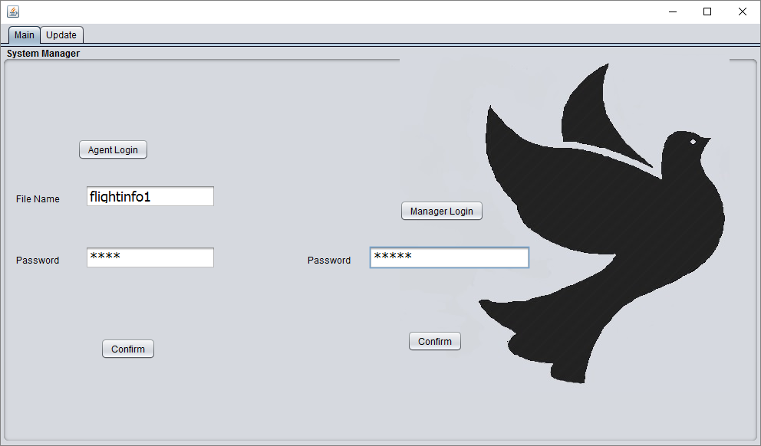

This provides the access to an agent or to the manager in charge by entering the relevant File Name or the Password.

If you are an agent the last updated fileinfo should ne given as the file name. eg. Flightinfox (here ‘x’ can be 1, 2, 3, etc.) Also 1234 as the password.

If you are the manager, you must enter 12345 as the password.

When you confirm the relevant details as an agent you will be able to visit the Agent’s Frame which will appear as below mentioned image.

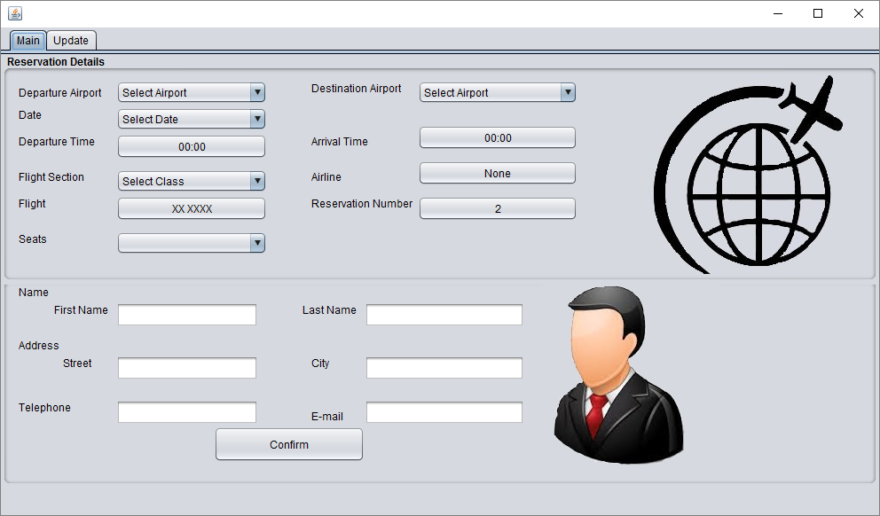

In the Main screen you’ll have to enter you reservation details.

* **Departure Airport**: You need to select an airport which you prefer for the departure.

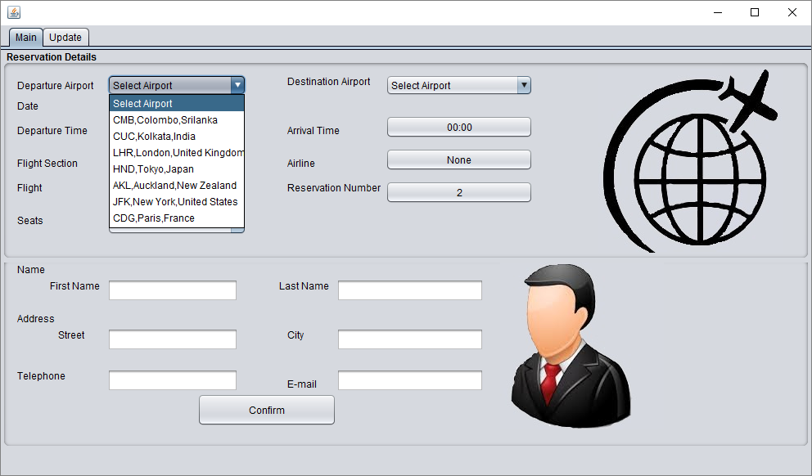

* **Destination Airport**: You need to select your destination. The airport you prefer for the departure will not be selected here.

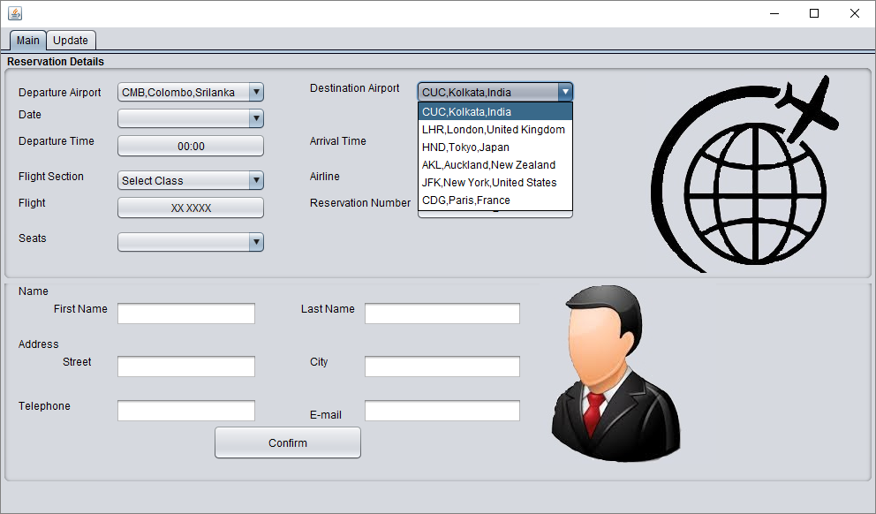

* **Date**: This selection box will helps you to choose your desired day.

If the selection box is empty it means there’s no flights for your destination from the departure airport.

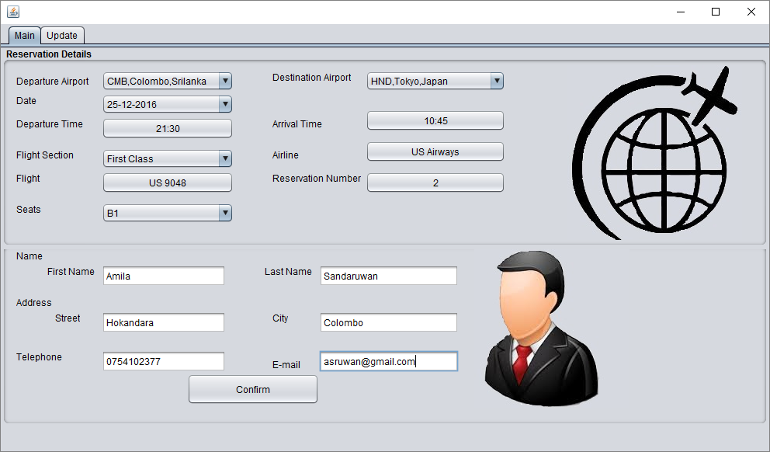

* **Departure Time**: This will inform you the time of departure from the airport.
* **Arrival Time**: The time of arrival at the destination is displayed here.
* **Flight Section**: You can select your desired class here.

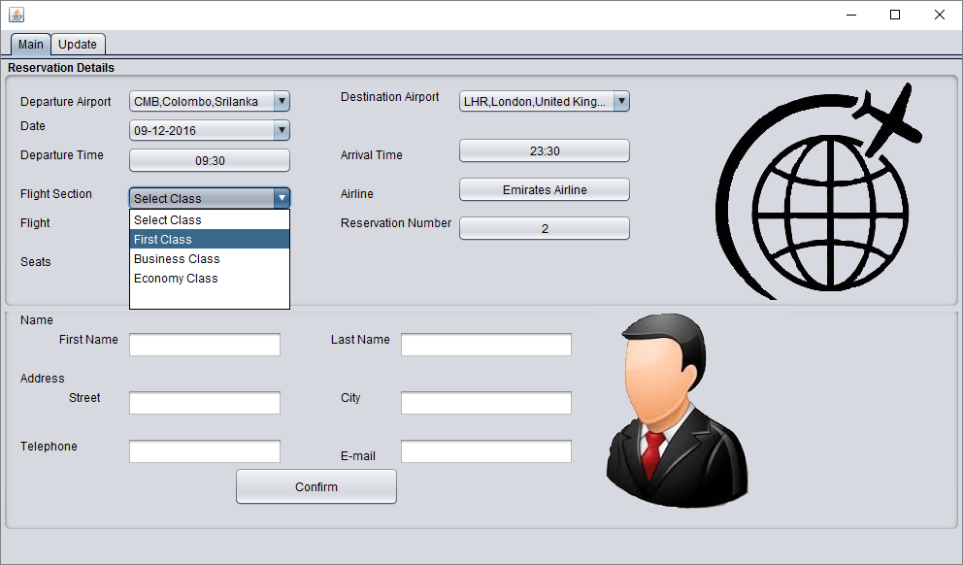

After you select the class you’ll have to reserve the seats for your tour. You can select the required seats simply by clicking on the check box in your preferred flight section.

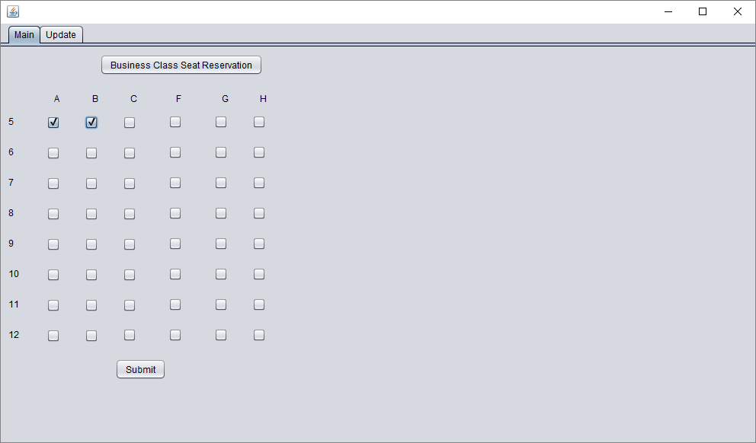

* **Flight**: Your reserved flight number is displayed here.
* **Reservation Number**: Your reservation number appears here.
* **Seats**: The corresponding seats that you have reserved are displayed here.

**Passenger Details**

You need to enter the details of the passenger in the relevant places and confirm the details you entered.

Once you confirmed with the details you entered, the text files named *flightinfo* & *PassengerInfo*will be updated accordingly.

**Updating Information**

Update screen will allow you to make changes in the reserved flight information.

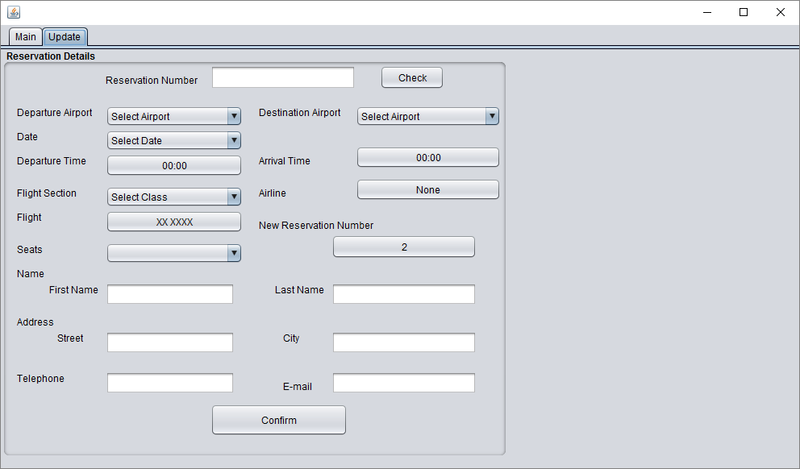

* **Reservation Number**: You must enter the reservation number of yours here and then check it.

When you check it, the information of your reserved flight will appear on the right side of the screen as **Previous Details** and you are provided with the ability to change the information as you desire which shows in the left side of the screen. Then you will receive a **New Reservation Number** and after confirming the details, new information will be updated as your reservation.

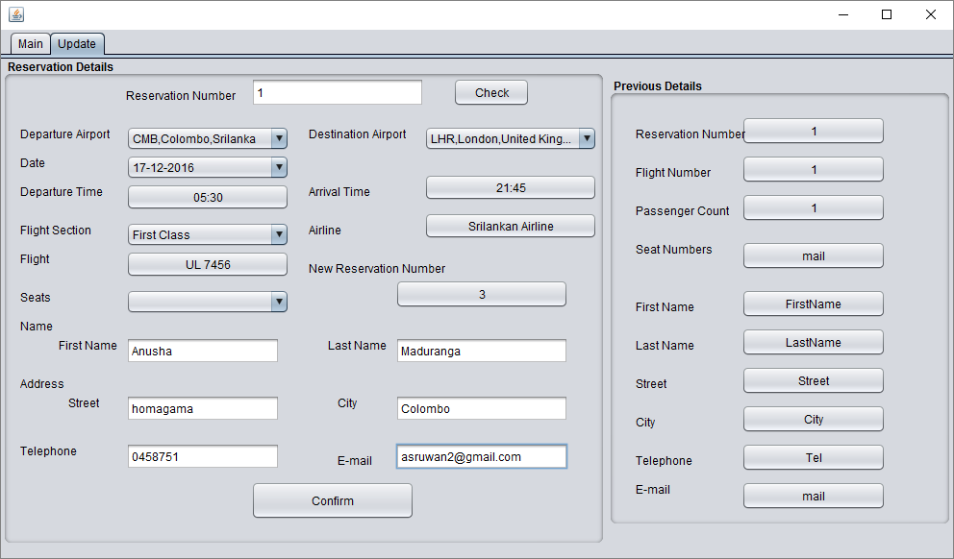

* **Manager Frame**

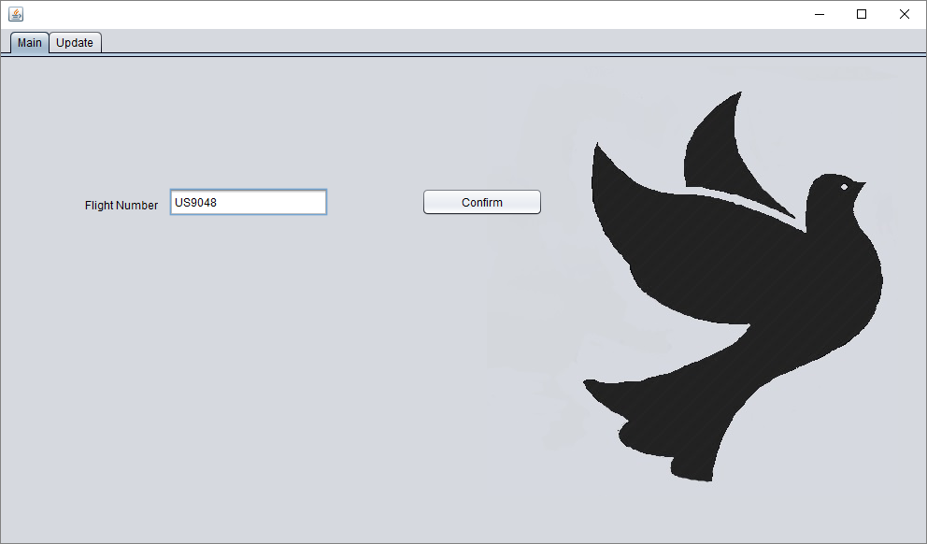

The manager need to enter the Flight number in order to access the details of the referred Flight.

When the access is granted the manager will able to see the document file of that flight.

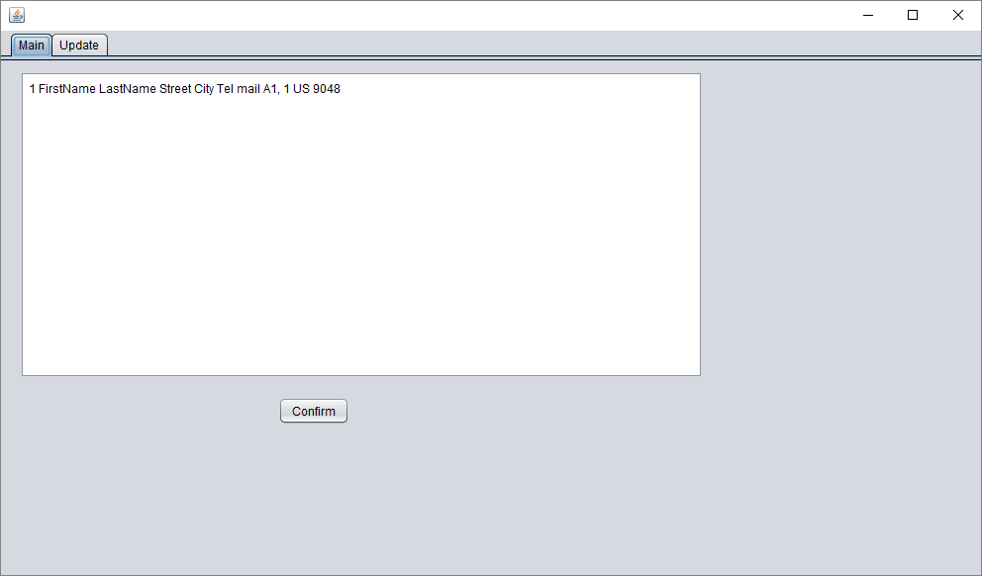

**INPUT AND OUTPUT**

The feedback from the agent acts as the main inputs of the system. For example File Name, Password, Departure, Destination and also the required class and the reserving seats are the inputs.





Outputs with respect to the above mentioned inputs are Departure Time, Arrival Time, Flight, Airline and Reservation Number.

The objects are connected by links, each link representing an instance of an association between the respective inputs and the outputs.

**IMPROVEMENTS AND EXTENTIONS**

There are some issues that arose when constructing this project. On the whole we must state that there should be some improvements in several parts.

* New agents unable to login as the password is the same and the same situation is faced by the managers.
* In this project the ability of updating the information of a reservation is compromised as the newly updated information will be saved as another new reservation but not as an update of the current file.
* The abilities that serve the manager must be improved.
* The document that saves the information of the reservation need to be edited so that it will clearly mention the required information. Currently this document shows the information in messed-up columns
* Another considerable development should be done in the Agent’s login is approving the agent to make more than one reservation. This still allows only one reservation at a time and if he/she want to make another reservation he/she must login again for the site.
* Ticket prices are not yet included in this system and it is a necessary fact to be displayed through the system.
* The ability to enter new flight schedules is difficult in the system. This must be further extended to satisfy the needs of the users.

Therefore above mentioned are the parts that must be further developed in order to bring the project to the expected level. Our team hopefully waiting to make these modifications in order to render a virtuous service through this project.

**PROBLEMS ENCOUNTERED**

When we were building up the project we had to go through tremendous difficulties in programming. When we were coding we faced issues where the output becomes true although it appears logically invalid, as a result we had to pay much attention regarding the most accurate logic. Another great effect was faced when entering the password, as we did not aware about the necessary code lines. We were able to overcome that difficulty by searching for the code via google. Also another difficulty was raised when connecting the departure and the destination combo boxes and in selecting relevant date for the selected destination. However we could manage and overcome the problem.

The major problem faced during the coding was appeared during selecting the class of the flight and reserving the seat. No matter how much we tried to make to get the selected seats in to the *Seat* combo box, we were unable to get the selected seat numbers unless it appears repeatedly. So it shows repeatedly and we had to skip the problem. We hoped to connect the check boxes that appear in selecting the seats via a loop, but we were unable to do so and we had to choose *IF block* and asa result the code got many extra lines. It was difficult to input data to the *Manager* *Frame* so as a solution we added many panels to the frame.

**TEST PLAN AND TEST CASES**

When developing the system careful study and observation of the system was done continuously. A series of test plans were done in order to make sure the functionality of the system is as we were expected.

We tested that the designed system ensures the purpose that we expect from it. We ran the programme with several test data and be aware of the error messages displayed for incorrect and the validations of the inputs and the outputs were tested.

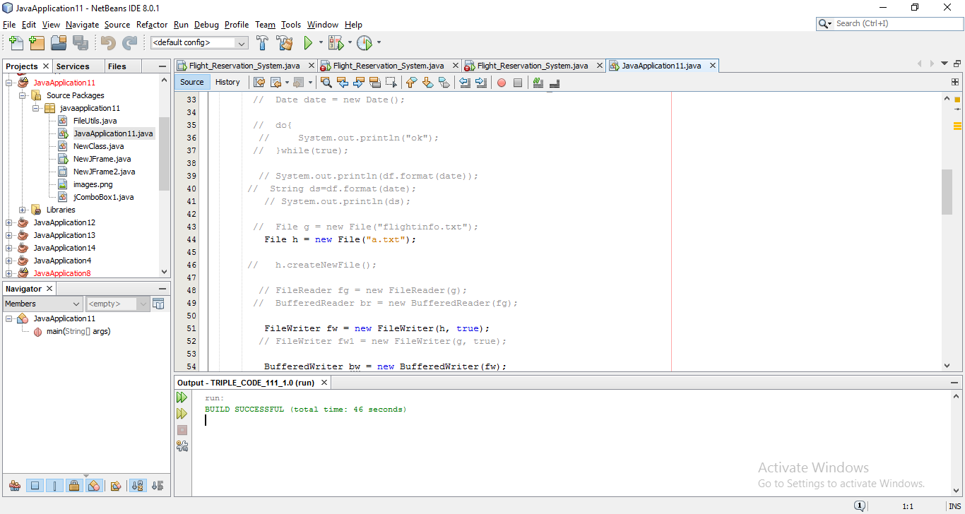

The problems that arose while the component interactions were handled and the performance of the system was tested by entering data. A series of tests were conducted to ensure that the internal operations are performed according to the specification.

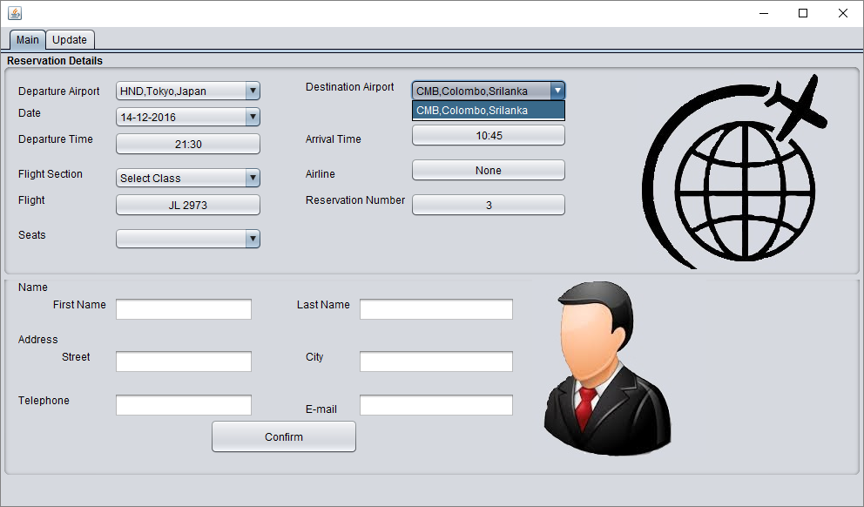

**CONCLUSION**

On the whole the entire project has been developed and launched according to the requirements of the user. With respect to the testing standards that are implemented the project found to be with minimum errors and bug free. We hope to develop further more by recovering and paying the concentration on specific untraced errors.

We can proudly recommend this project to put forward in the field of airways. We also ensure that the capabilities arrive through this project will be much more helpful in achieving the requirements of the users.

In this project we had to think about the various options which we can provide to the user. We have tried to make this project user friendly and also interactive by providing many features

Finally, we like to conclude that we put all our efforts throughout the development and tried to fulfil most of the requirements of the user.